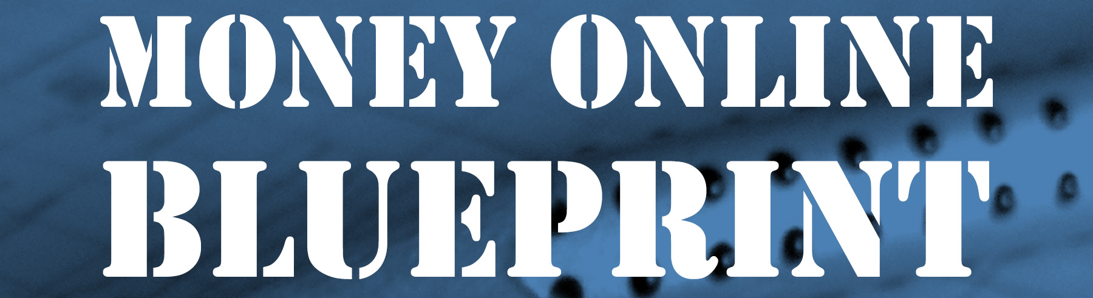

Consultation with Chris Cantell Details

Thank you once again for your purchase of a consultation with Chris Cantell.

Can you please now complete the table below and send this document back to the following email address: - support@chriscantell.com

Your Name

Your Email Address

Your Payment Transaction Number

What consultation did you purchase?
(e.g. 30 Mins or 60 Mins)

In the table below, please provide as much information as possible about what you would like to talk about during your consultation with Chris Cantell

What do you hope the consultation will do for you / your business?

